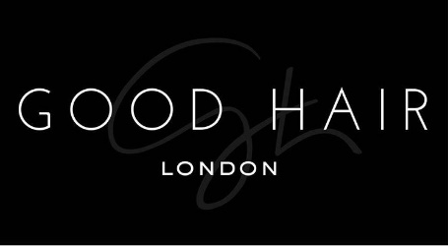

Job Description

Thank you for your interest in working with Good Hair!

We are passionate about our people; they are the bedrock of our business, which is why we invest time and effort in recruiting the perfect match! Our employees are passionate about Good Hair, their role and the overall success of the company. We are all motivated to drive our own success and achieve individual objectives. Communication is key to any role here as our employees continually build relationships with our customers and at all levels across the business.

We’re fast paced, so all employees need to able to adapt to change quickly, be enthused and excited about what’s around the corner for us.

Job Title: Hair Stylist

Role: Full-time (is this a full time role or a part time role)

Location: 1 Olubunmi Owa, Lekki Phase 1, Lagos.

Start date: (when would you like the candidate to start?)

Role background:
Responsibilities include cutting and styling hair using basic and advanced techniques, consulting customers about styles, colours and applying hair care products, like treatment oils, moisturizers and masks.
Your goal is to ensure that all customers leave the salon satisfied with our services and are happy with their new looks.

Role functions:
- Recommend hairstyles and haircuts according to customers’ face shapes and tastes
- Book customer’s appointments with efficient time allocated for each appointment
- Wash, rinse and dry clients’ hair using appropriate shampoos and conditioners (e.g. for oily hair or dry scalp)
- Create hairstyles for formal events and everyday looks, including braids, ponytails and buns
- Apply hair treatment products, as needed (e.g. colour protection creams and hydrating masks)
- Form bonds with loyal customers and remember their hairstyle preferences
- Ensure tidiness of beauty stations and sterilize tools, as needed
- Cross-sell hair care products or services, when appropriate
- Manage bookings and serve walk-ins

Key Skills and Requirements:
- Work experience as a Hair Stylist, Hairdresser, colourist or similar role
- Proficiency in hair straightening and curling methods, using hot irons and curlers
- Knowledge of a wide range of haircuts, suitable for all hair lengths (e.g. braids and top knots)
- Familiarity with hair treatment products and services, like keratin smoothing
- Excellent communication skills
- Physical stamina to stand for long hours
- Up-to-date with industry trends.

The ideal candidate:

- Someone who is level headed and up to date on fashion trends
- Someone who is passionate about fashion
- Someone who is confident and can communicate excellently
- Someone who takes a professional and committed approach to work
- Someone who gets involved and contributes with feedback and ideas to continuously improve Good Hair

All interested individuals must send a cover letter to GoodHair@rensan.co.uk, detailing why they should get the job and what they believe they can add to the business. Attach your CV and ensure you use subject title ‘Good Hair Admin Manager’.

Failure to apply in the way we have specified will disqualify you immediately, please ensure that you read thoroughly. Please also note that if your application is successful we will contact you.

